**Deploy Application on Cloud.**

Set-ExecutionPolicy RemoteSigned

Run the project using the command ng serve. Now the project is running in the port 4200.

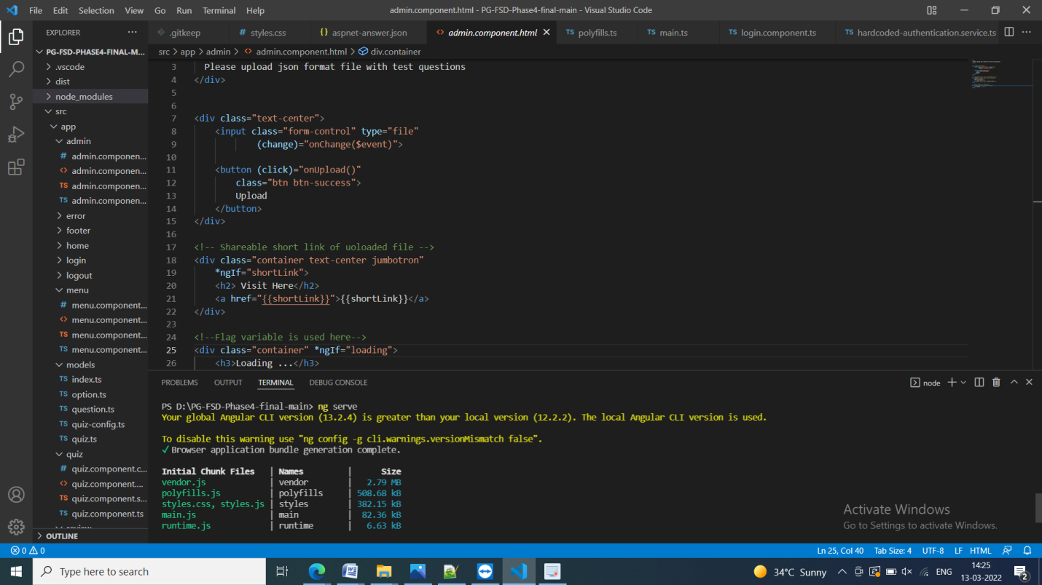

Run the project in localhost:4200

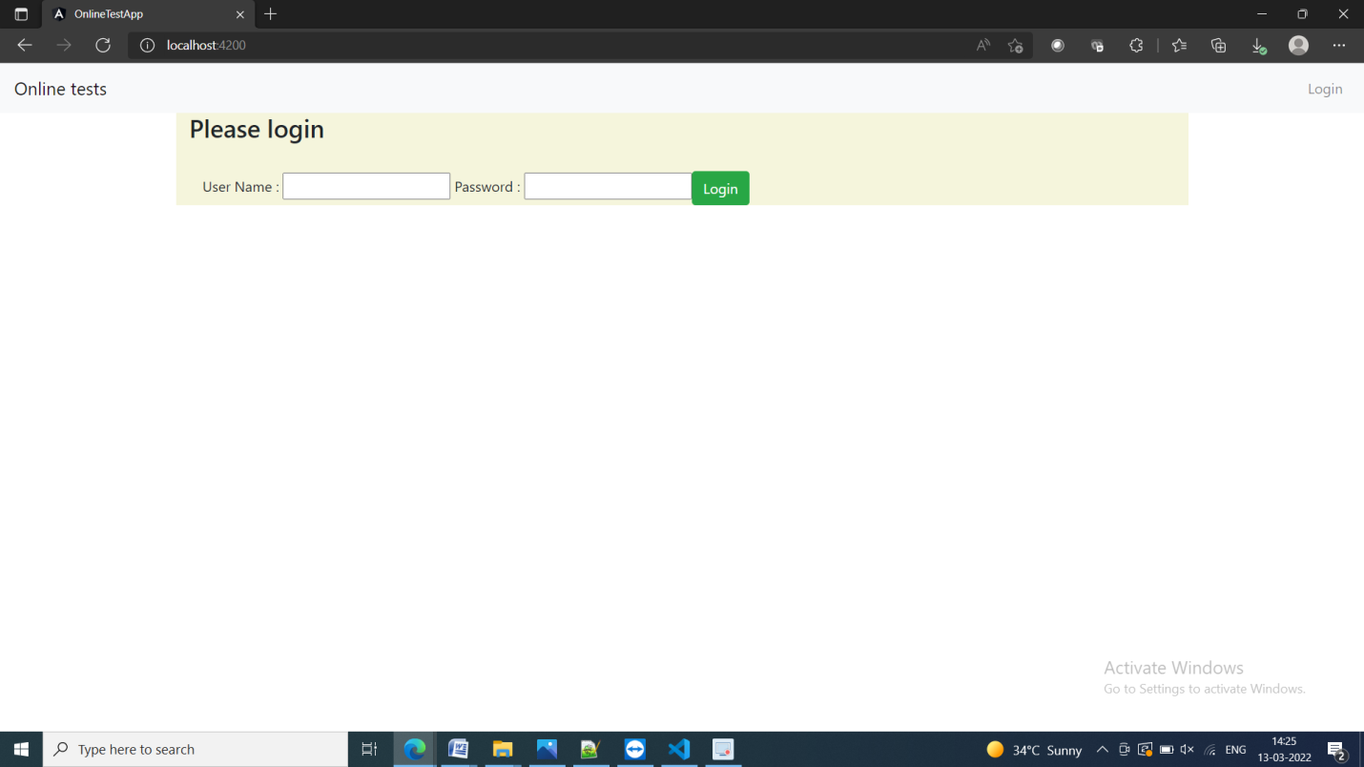

Create a zip file of the project by ng build command for connection perpose

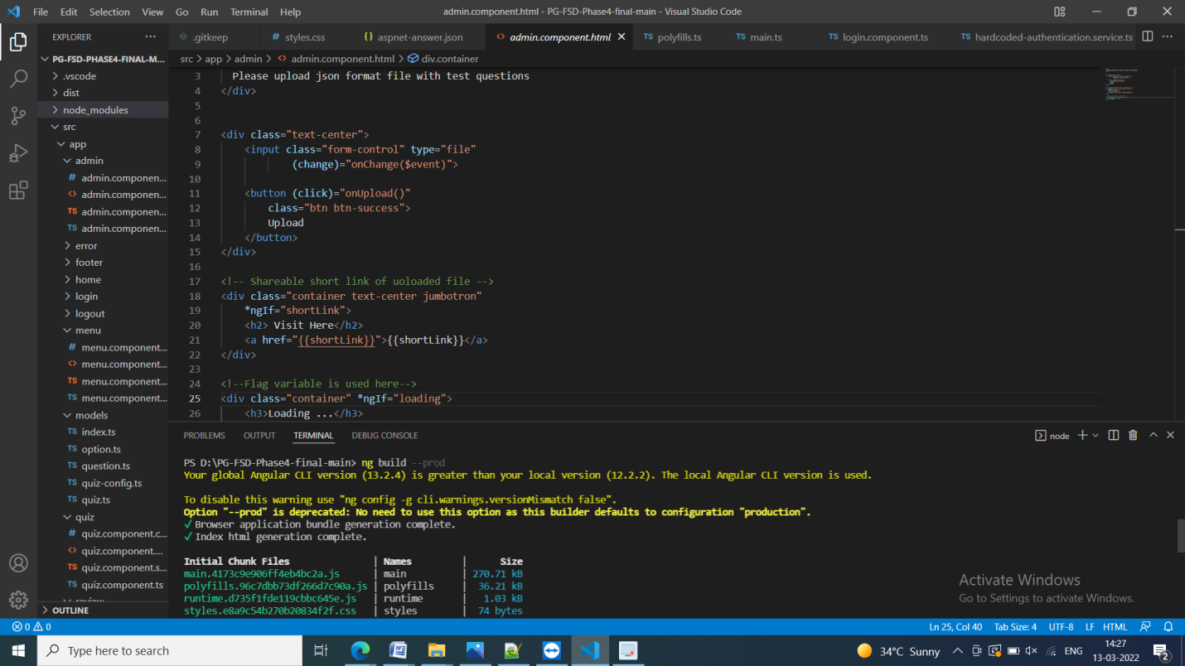

Create a EC2 instance for connection

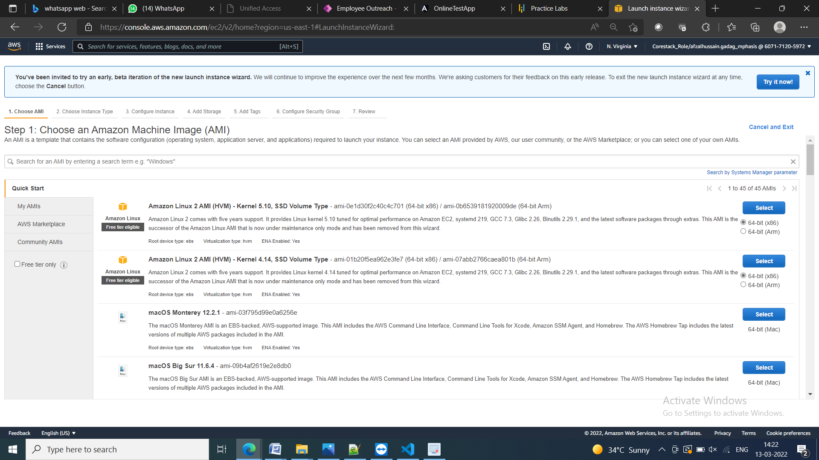

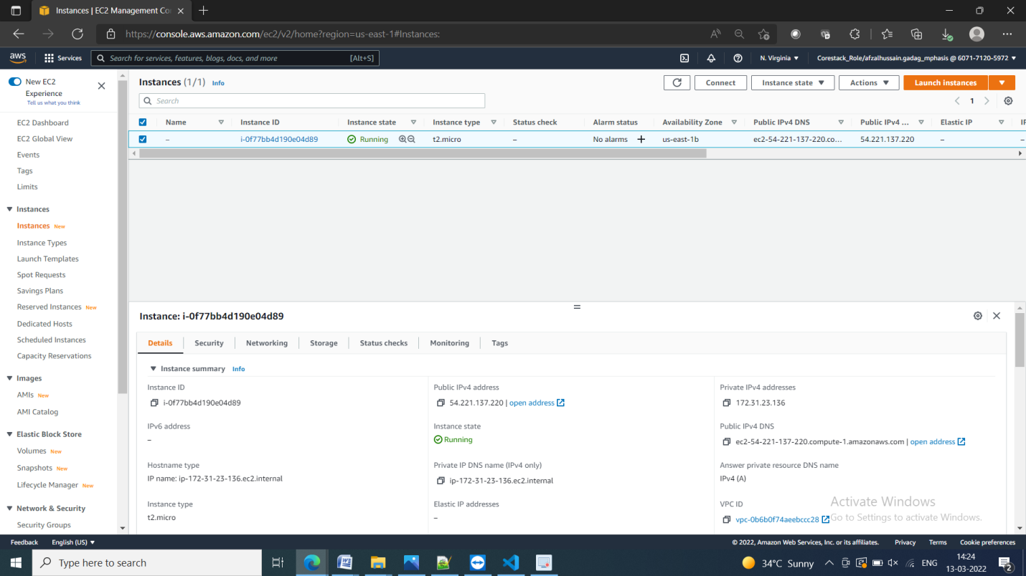

Create a IAM role

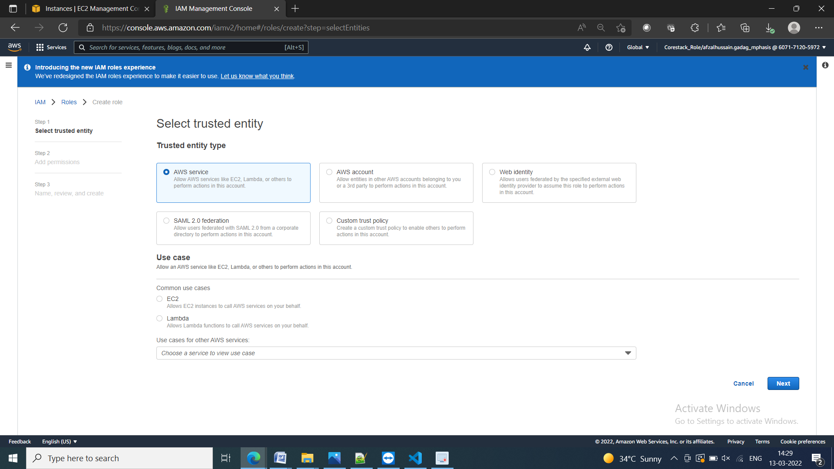

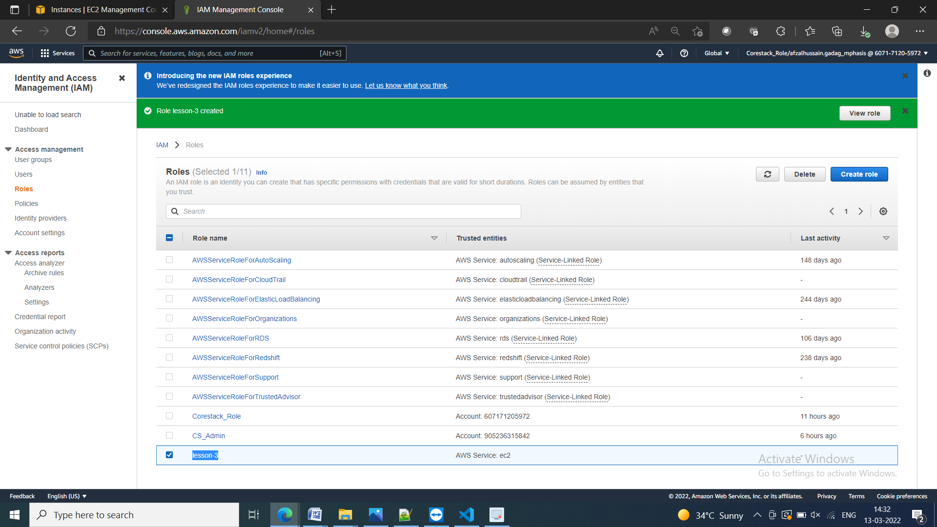

Modifie IAM role of the instance created

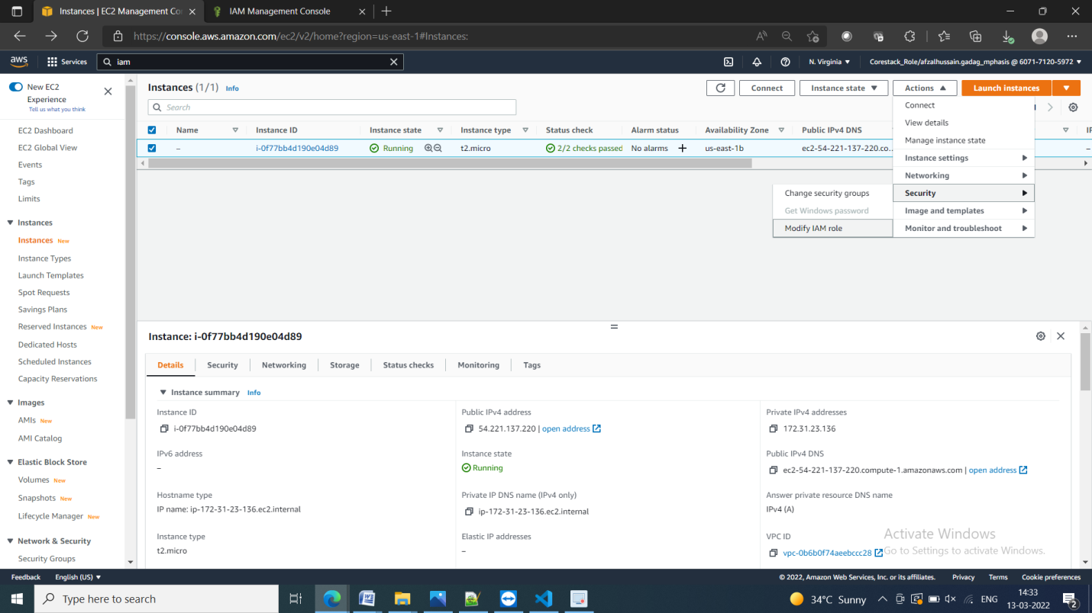

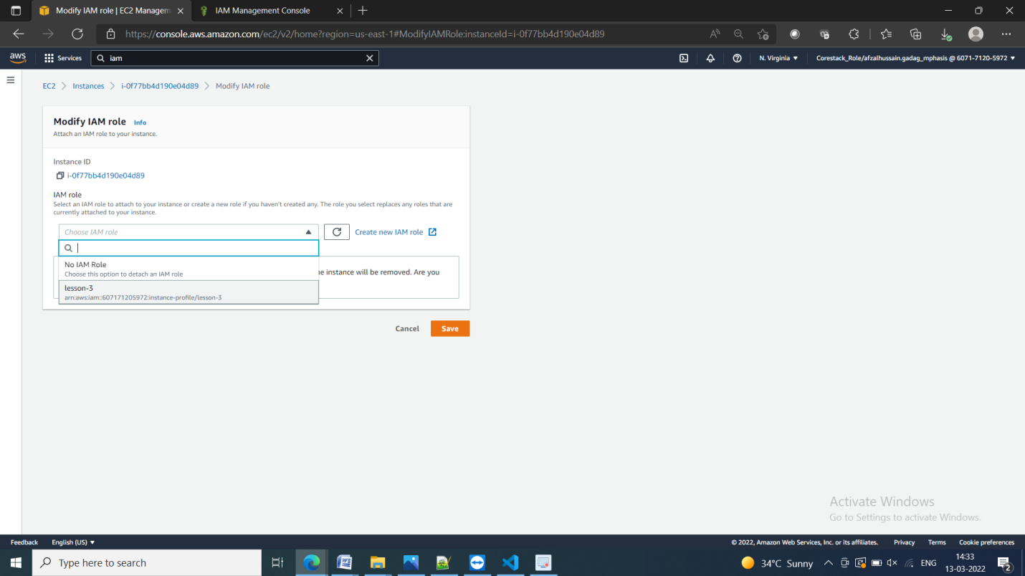

Create a s3 bucket

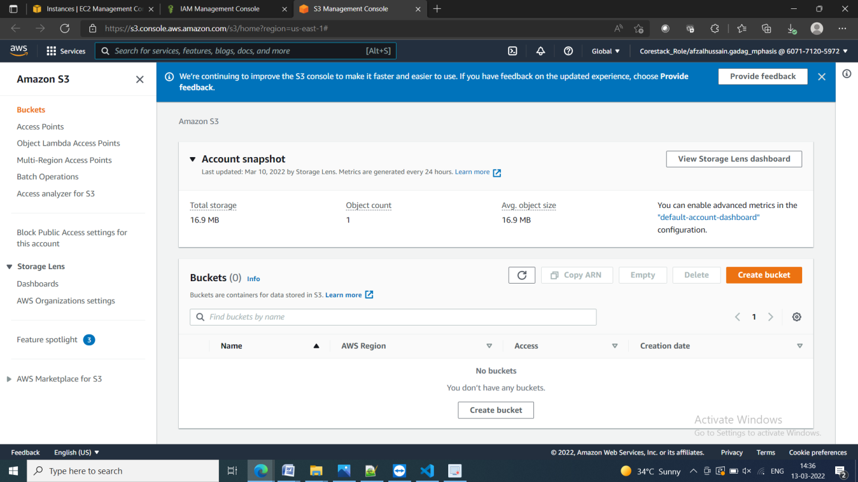

Give a unique name to the bucket

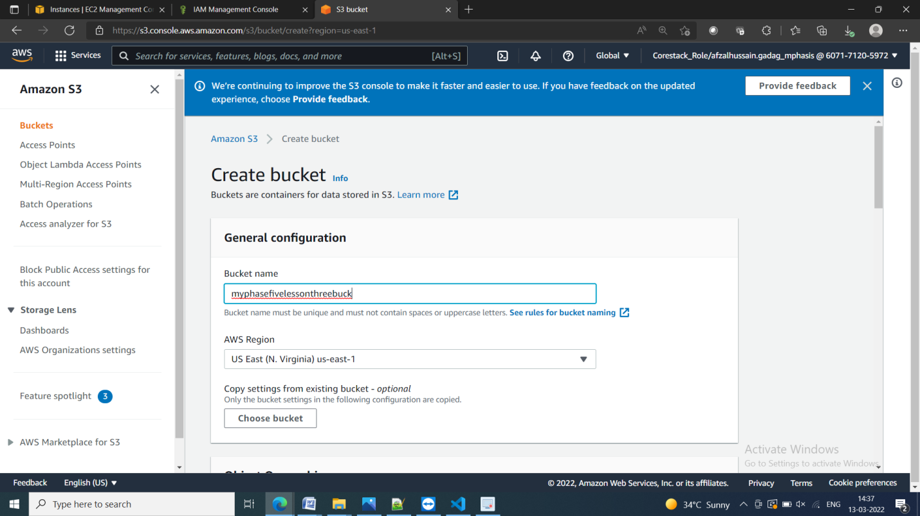

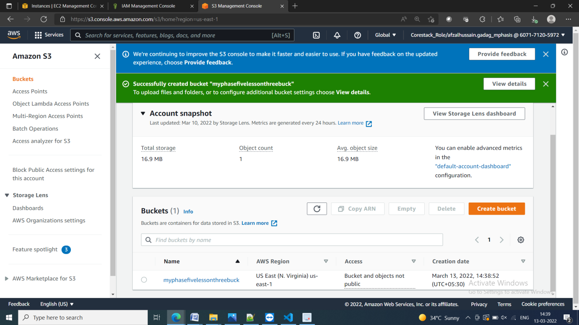

uplode zip file of the build project

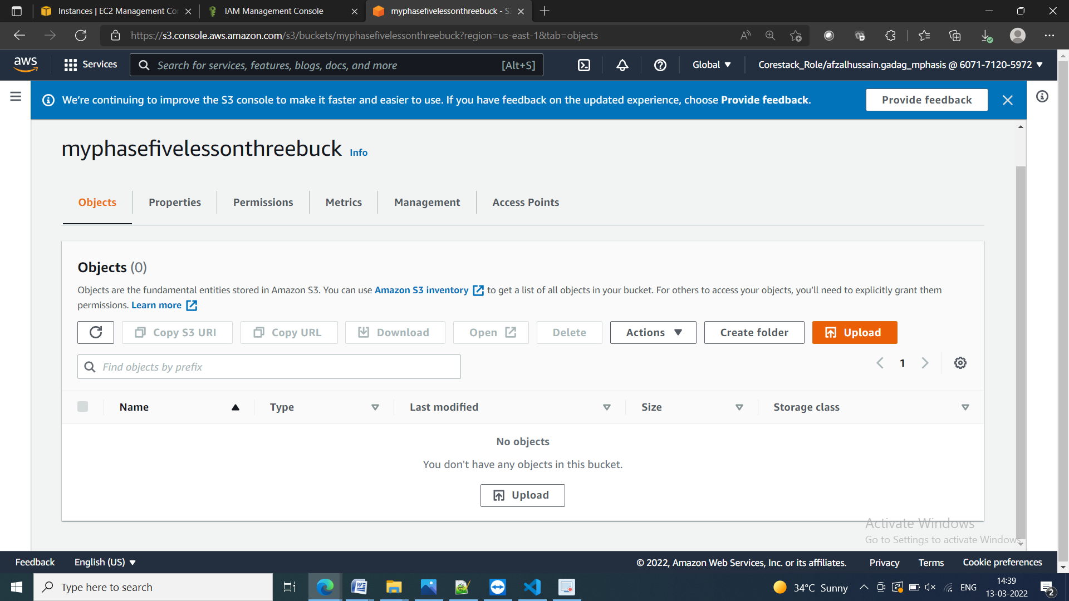

Uploded sucessfully

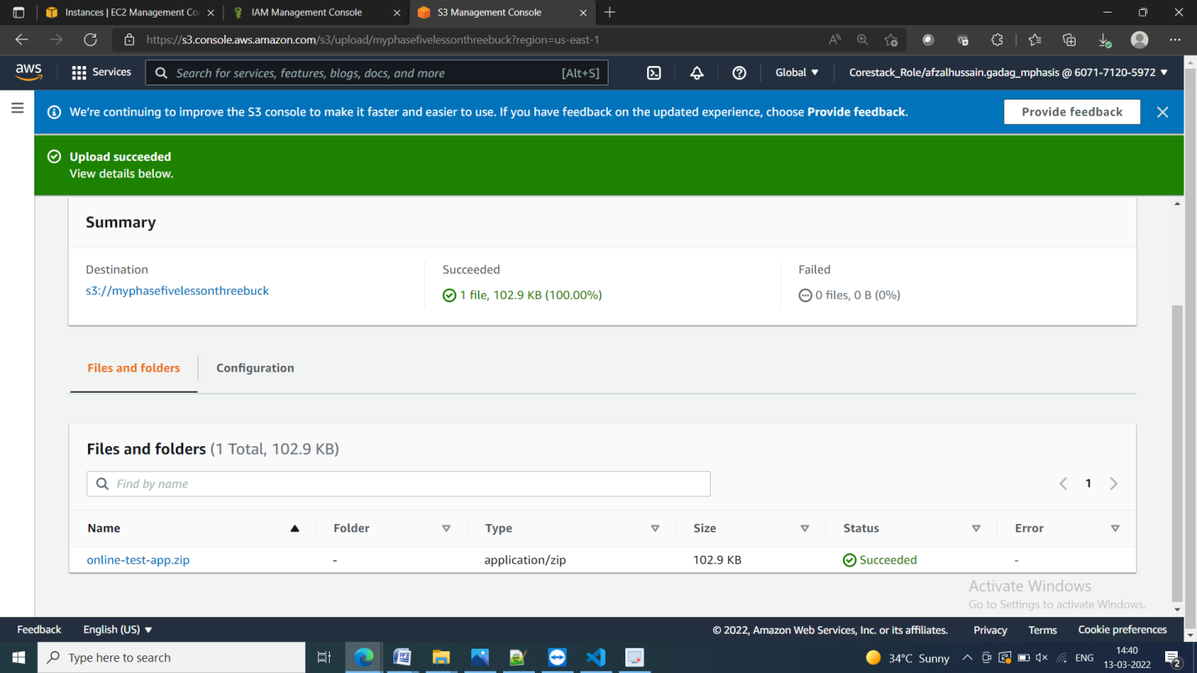

Conect to the EC2 instance.

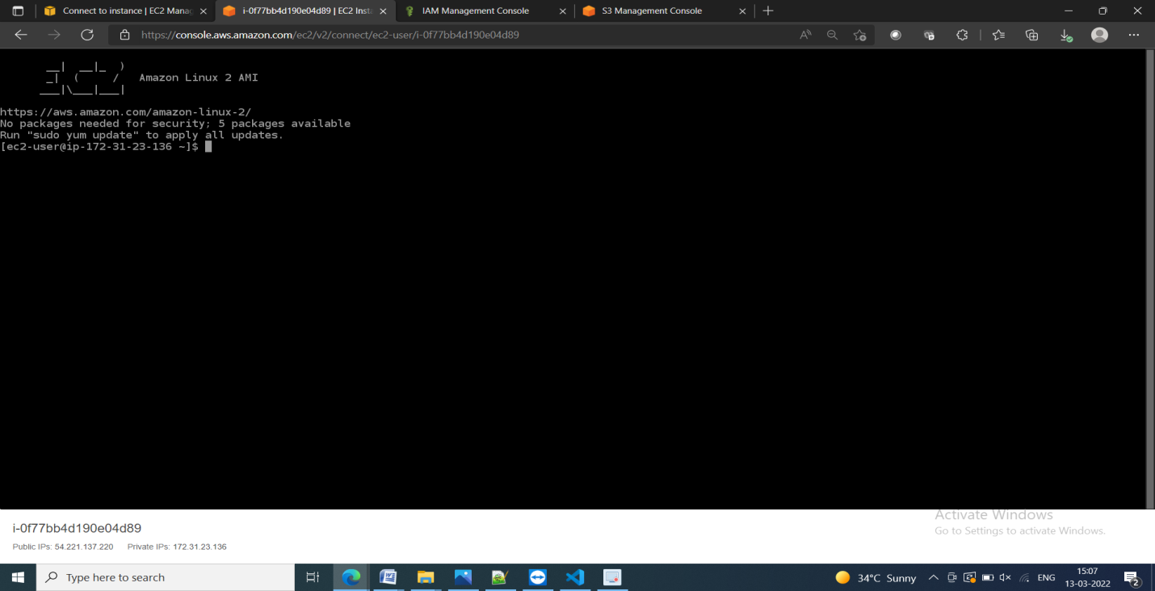

1. Sudo yum update –y
2. Sudo yum install httpd –y
3. Sudo systemctl start httpd
4. Sudo systemctl enable httpd

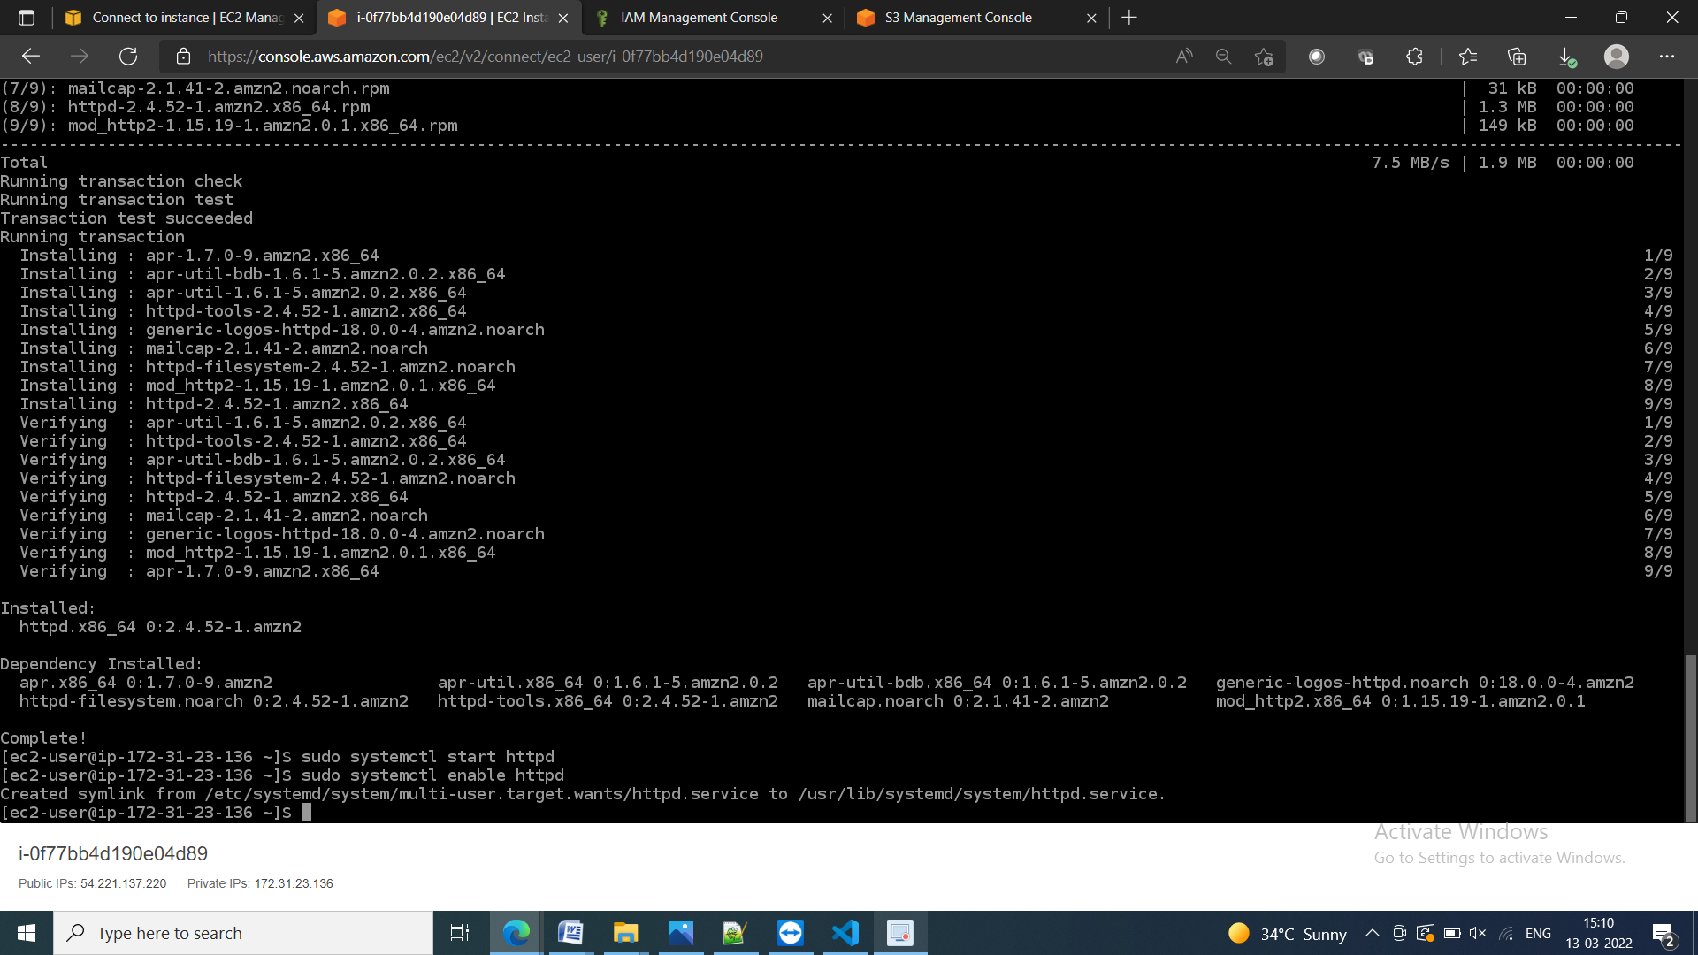

1. Sudo chmod 077 /var/www/html

Make bucket public for accessability

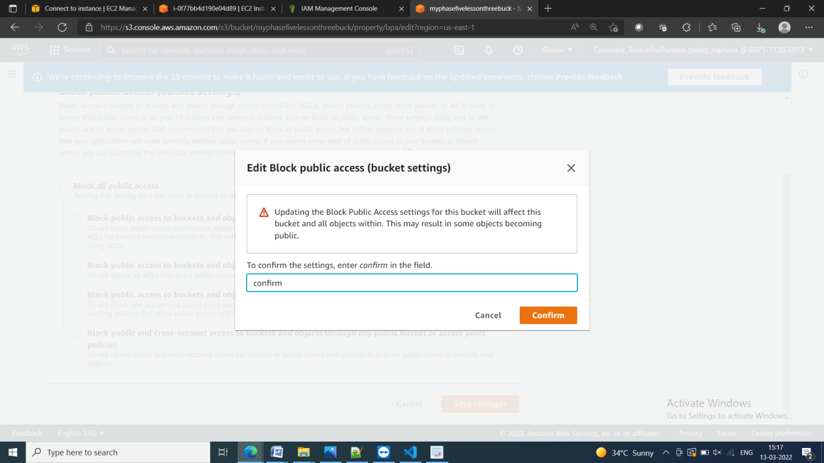

connect S3 bucket to the EC2 instance

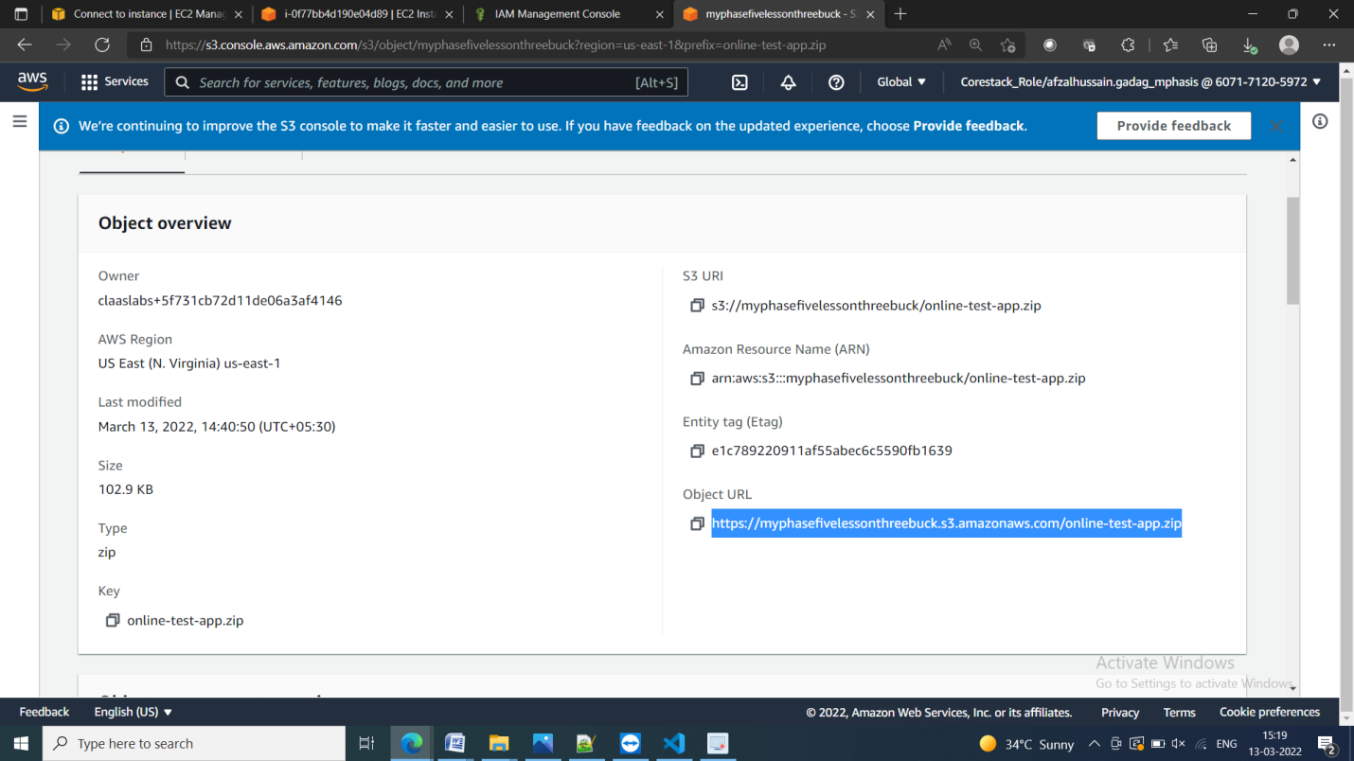

S3 bucket is connected to instance

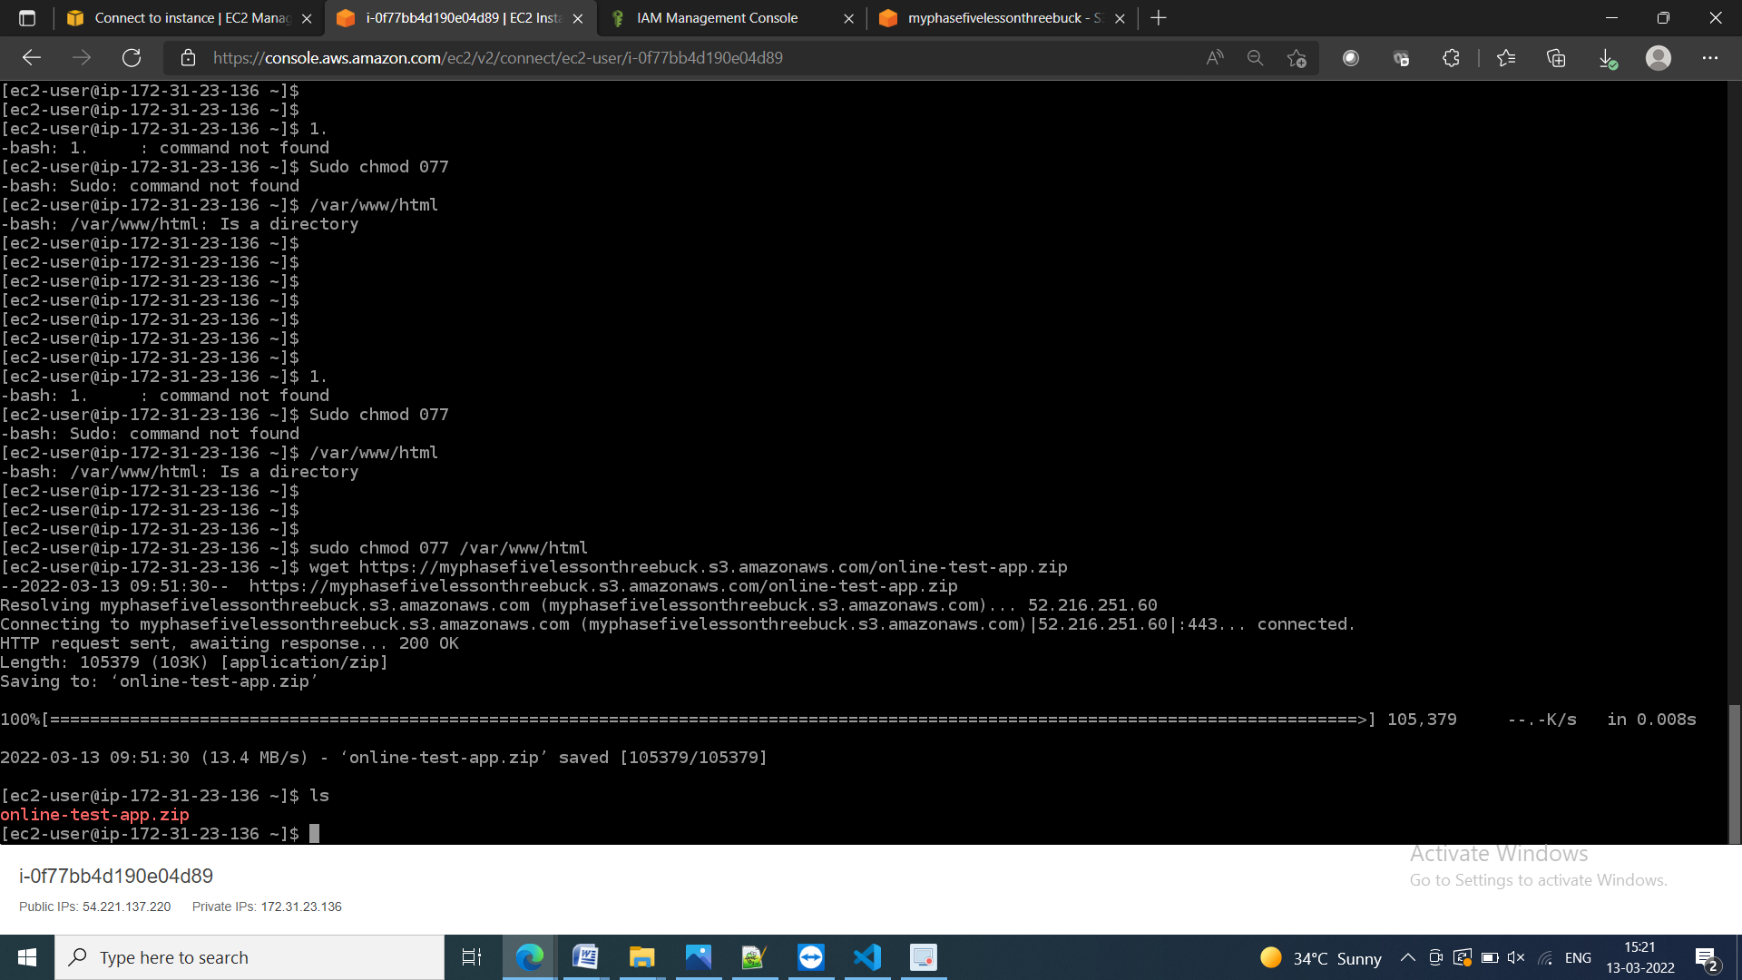

Unzip the file

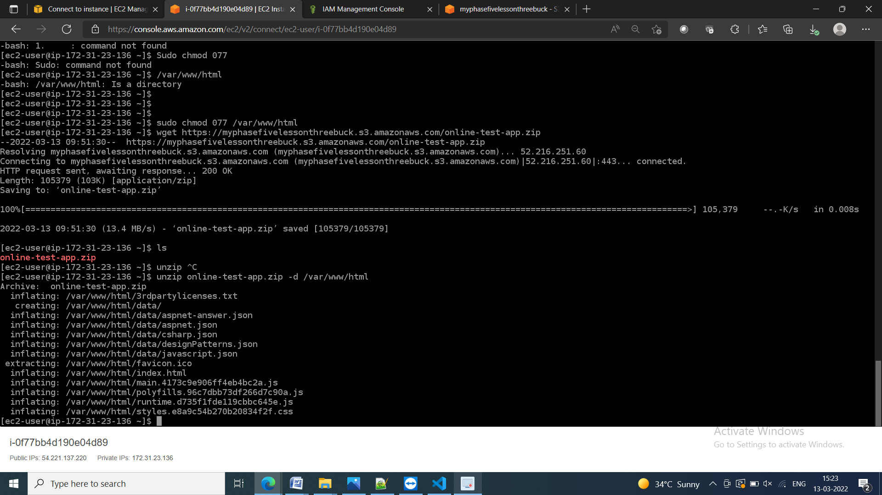

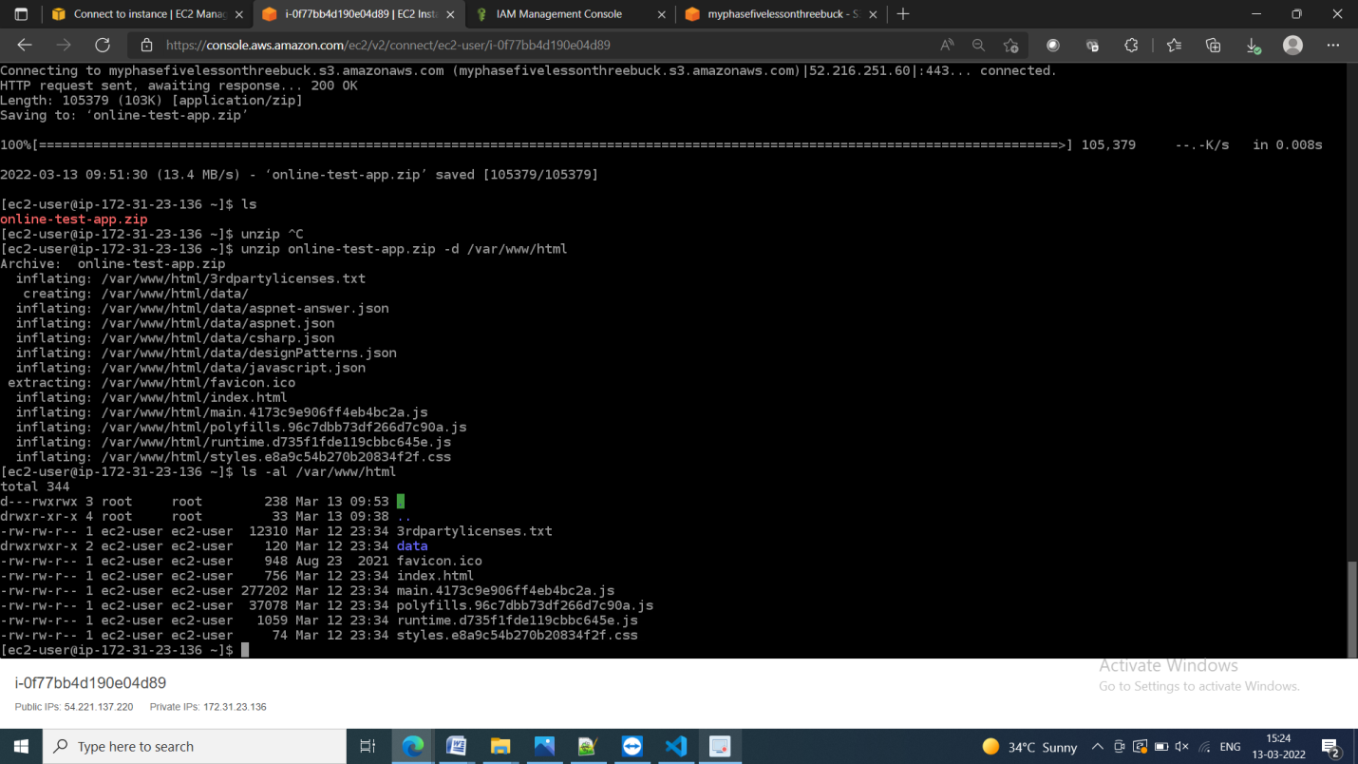

Now run the project using instance public ip address

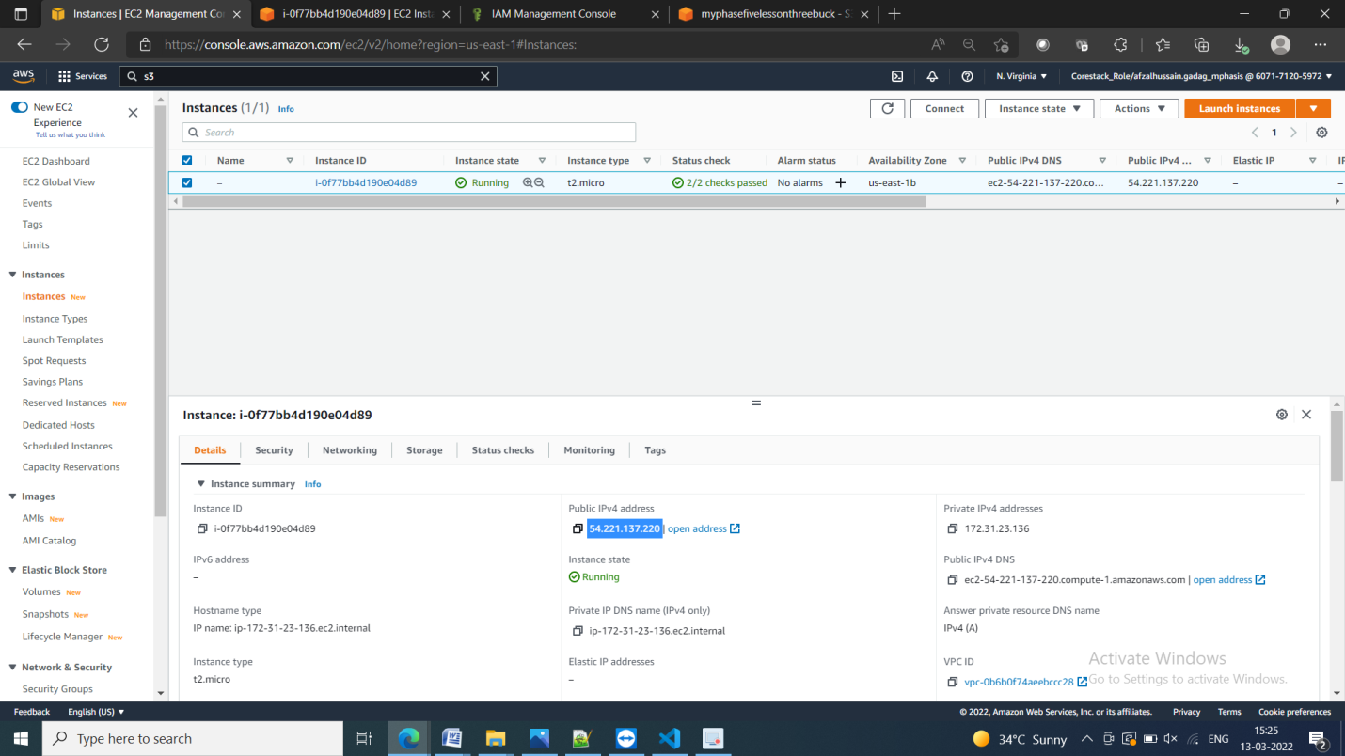

Output of project through instance

